**Needfinding Project**

Mercado, Rainer Maalik A.

Durante, Lorenz Miguel C.

BSCS-SF 181

UI/UX Design and Programming

**Activity**

Coffee Vending Machines in School (Asia Pacific College)

Having students who constantly focus on their everyday schedule, may it be students who have a hectic time or students who love drinking coffee on a daily basis. The school has put up different coffee machines on specific floors for people to buy a cup of coffee in less than a minute. These coffee machines prove to serve its purpose for many people, specifically students, as they give a much better reaction when having coffee machines to be accessible for many.

To efficiently keep students’ mind awake and fully active. We have considered that having a coffee machine is highly beneficial and is considered a factor for students’ daily school life. It is also important that that convenience comes into play. On a daily basis, we will always find a person that buys a drink at the coffee machine. An idea that can be improved by using Needfinding.

**Observations**

We spent three days (Monday, Tuesday, Thursday) observing different people on accessing the coffee vending machines. Floors from 1st, 7th, 10th were observed the most, since this is where the coffee vending machines were located. All in all, we spent about 3 hours on monitoring the coffee vending machines during our lunch break. We monitored anything that could be a considerable factor on why people find it inconvenient to access such coffee vending machines.

**Interviews**

For our interviews, we asked 3 different students who are currently studying at APC. All of them have been using the coffee vending machines located at different floors of the school premises. We asked them the same set of questions, for each interviewee.

**Interviewee # 1:** James Martin Sta Ana, BSEMC-GD Student



**Question 1: How often do you buy a drink at the coffee machine?**

“I guess you can say I go there pretty often, especially when I’m very sleepy, which I am in most days”

**Question 2: Do you find it convenient to have a coffee machine at school?**

“Yes, whenever I’m in a hurry to go to school, I tend to forget to make coffee at home, so I just buy them here”

**Question 3: Do you think we need more coffee machines at school? If yes, why?**

“Yes, the current ones are located at the caf, 7th and 10th floor, what if I’m on the 5th floor and I’m in need of a quick drink? So yes, we need more”

**Question 4: Have you ever had any problems with buying drinks at the coffee machine?**

“The biggest problem I face is that I tend to always have new 5-peso coins and the machine needs the old ones”

**Interviewee # 2:** Reign Mina, BSIT-MI Student



**Question 1: How often do you buy a drink at the coffee machine?**

“Yeah, I drink every day.”

**Question 2: Do you find it convenient to have a coffee machine at school?**

“Yes, I find it convenient because I don’t have to go outside or bring my own coffee to get a cup daily.”

**Question 3: Do you think we need more coffee machines at school? If yes, why?**

“Yes, we need more so there’s less distance to walk for a coffee machine compared to right now we only have 3 coffee machines.”

**Question 4: Have you ever had any problems with buying drinks at the coffee machine?**

“My only issue is that there are times where I forget my coin purse at home or in the classroom.”

**Interviewee #3:** Ronn Angelo Lee, BSIT-MI Student



**Question 1: How often do you buy a drink at the coffee machine?**

“I buy coffee from time to time but not always.”

**Question 2: Do you find it convenient to have a coffee machine at school?**

“Yes, it’s very convenient to have them here because as college students, we need coffee to do activities.”

**Question 3: Do you think we need more coffee machines at school? If yes, why?**

“No, I think the coffee machines we have now are strategically placed so that we won’t need any more.”

**Question 4: Have you ever had any problems with buying drinks at the coffee machine?**

“I always have this problem where I wouldn’t have any coins, I would always have paper bills.”

**Identified Needs**

Based on our observations and interviews, we have found the following needs that could necessarily be a huge factor of improving Asia Pacific College’s facilities for the benefit of the APC Community.

* **The APC Community, most especially students, now need to have a better way to access caffeinated drinks.**
* Based on the answers of different people, it is very much better to have more accessibility with having coffee vending machines. It makes everything more convenient for the APC Community, and there can be no potential downside to APC’s side of business for the results of having a coffee vending machine shows potential for demand.
* **Students need a quick way for payment process.**
* Our interviewees have been finding different ways on having a payment scheme. It seems for us, and the students, that having only old 5-peso coins as the payment process, is very much lacking. Having different options such as accepting different peso coins, and a modernized way of paying could solve this problem.
* **Students need a wider variety of options for drinks.**
* There is no problem with having different drinks, it’s just that students much prefer having more variety of drinks for their different preferences. As of now, there are only 3 choices of drinks at the coffee vending machines. Having more, utmost 6 can solve this problem as this provides a more than enough choices for drinks.
* **Students need better features for the current one can improve on efficiency.**
* The lack of modernized features is another complaint from the students. Having the students to be the number one user of the coffee vending machine, they say that it lacks certain features. Making a more efficient way of accessing these coffee vending machines such as implementing an e-wallet system could potentially solve this problem.
* **Students need an alternative way for payment process.**
* The difference of having a different process and having a quick one is big. One is that having more than one payment process can increase sales upward. This is proven to be the fact that having different payment schemes can help students choose their proper way of payment, not just with coins, but also with e-wallets. Having these features can help solve this problem.

**Point of View**

**Few Options**

* Students, and the APC Community as a whole, need more choices of drinks instead of having just coffee for the offered drinks.
* Not all people of the APC Community would drink coffee or caffeinated drinks, some would just need a warm drink which can be non-caffeinated.

**Limited Use of Features**

* The process of payment is very old-school. There’s a need for modernization and better efficiency.
* The process of getting a drink is quite stale, and now there is a need for using modern features.

**Lack of Accessible Coffee Vending Machines**

* Students, and the APC Community as a whole, need to have a better way of accessing a coffee vending machine, for a coffee vending machine is only located at certain floors inside the school.
* Coffee vending machines should be dispersed around different floors for better convenience.

**Conclusion**

After a concrete analysis from our observations and interviews, we therefore conclude that the observations that we’ve made were aligned with how the APC Community interacts with the coffee vending machines. As for ourselves, we were also checking to see on how we would react if were to be in the same situation. Fortunately, and unfortunately, we are also part of the situation itself, therefore we also see this as a need to solve.

Problems that students mostly face is the fact that the coffee vending machines do not accept new 5-peso coins, and it is also very limited to only having old 5-peso coins for payment. As we continue to transition with the increasing number of the new 5-peso coins, there is also an increasing grow of need to find a better way of payment for acquiring a drink from the coffee vending machine. This has been considered a restriction for the user simply because of the lack of versatility of the machine in terms of payment process.

From this problem, we’ve acquired different views on how we want to solve this need. The solution will mostly rely on modernizing the coffee machines and making sure that accessibility wouldn’t be a problem. Having a modernized way of dealing with coffee vending machines can conclude to an increase in profit and overall satisfaction for APC, and the APC Community. Making sure that each feature could present a possible option for the user to determine and use, will prevent complains in the future about proper usage of the coffee vending machines.

From these needs, we have concluded that these solutions would be the most optimal and most positive outcome of providing a way of implementing efficiency and cohesiveness of features. This will benefit the APC Community as a whole, lessening the inconvenience and providing more ways of accessibility and satisfaction.

**Wireframes**

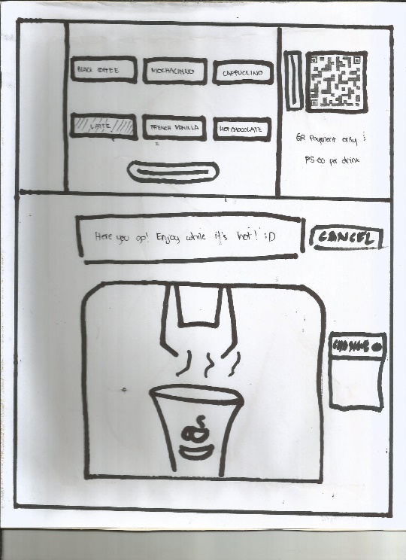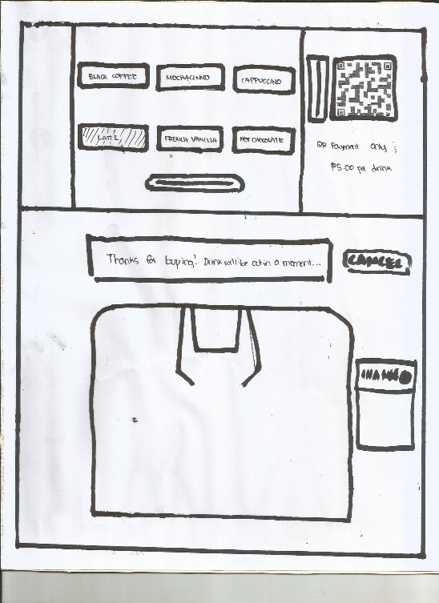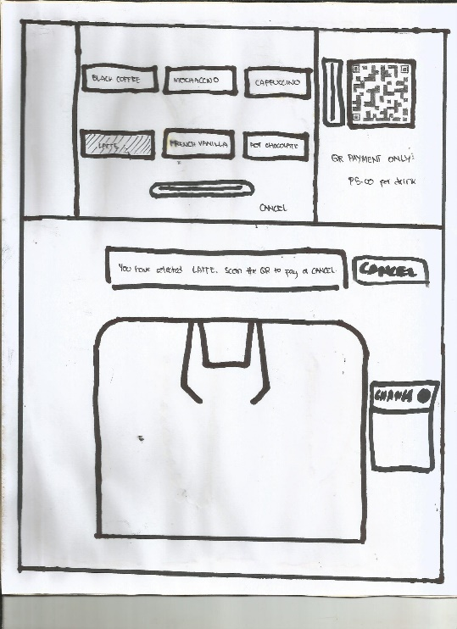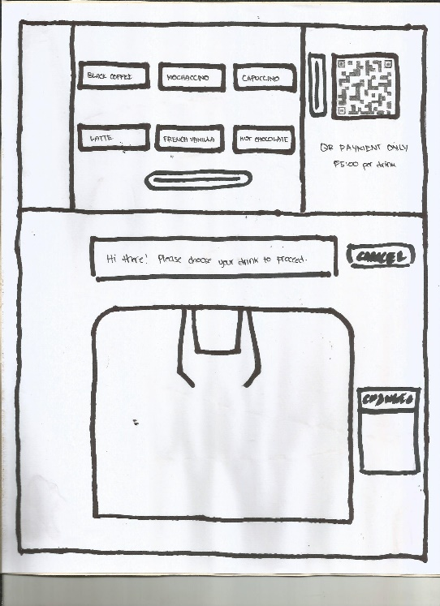

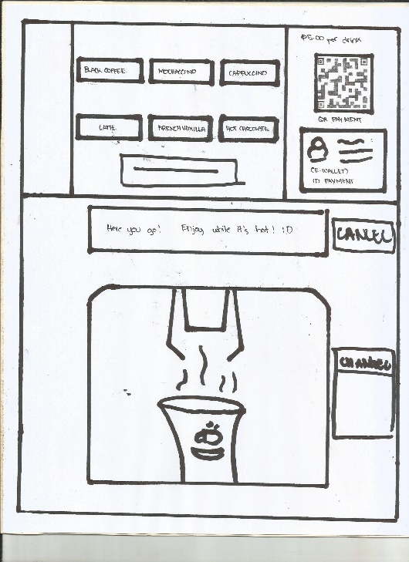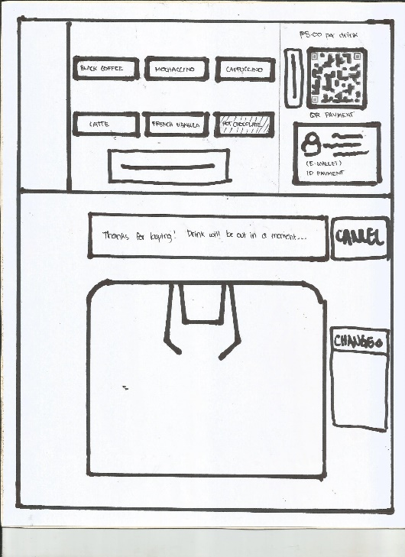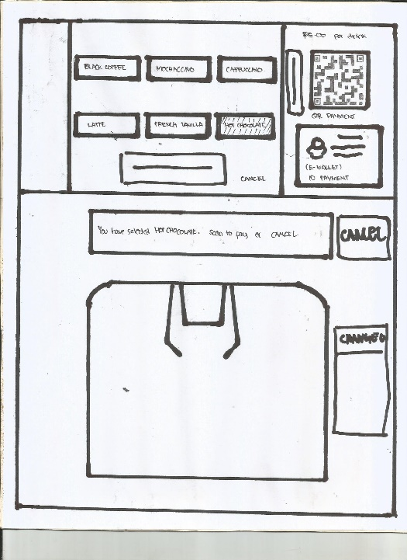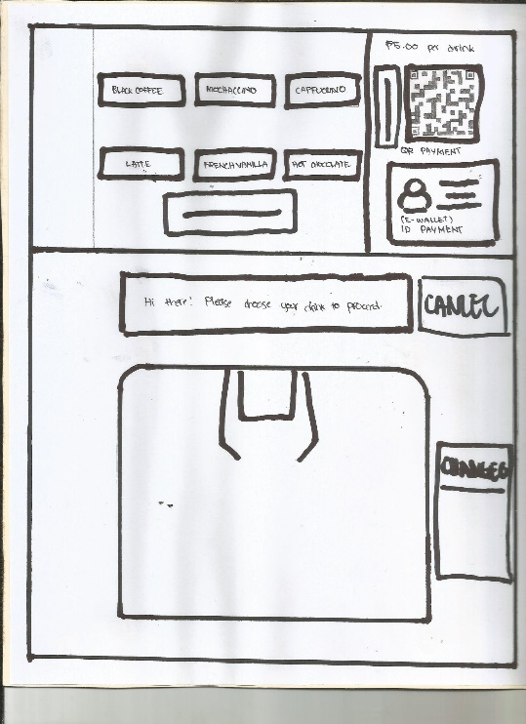

**Links**

https://github.com/LorenzDurantz/userdesSF181A1-LorenzDurantz-ramercado29

https://coffeevendingmachine.herokuapp.com